**Fielding 2.0 – Poles**

The new pole block used to record field data is called “sPole”. The image below shows the list of attributes attached to the block.

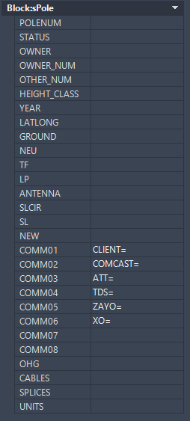

The attributes begin with the general pole data which starts from the pole owner to the ground source.

Verify pole owner and change if necessary.

Add the owner pole number is displayed.

If there are any other pole numbers add them like COMPANY=NUMBER. There are some companies with shorthand or aliases and you can find the list within the drawing. See the “Fielding 2.0 – Alias” document for what they look like and how to add more.

Hopefully H-C is already filled out, but add/modify if you can read the birthmark.

Doubt you will be able to figure this out the year of the pole.

Latitude and longitude will be added by the program.

The ground source should always be filled out. There are some sources with shorthand. n=NO GRD, m=MGNV, t=TGB, and b=BROKEN GRD

The next section is for the power attachments which start with the neutral and ends with street lights. If there are more than one attachment for any attribute, separate them with a space.

The next attribute is to record any new attachments. This will be filled out by the Make Ready crew. If you find a tag on the pole for a future attachment of our client, add the height in this field and add ”t” at the end to show it is a new tag.

The COMM section can be used for any company’s attachments. The format to fill out the attribute is COMPANY=ATTACHMENTS. The attachment heights need to be separated with one space. Below is a list of suffixes that you can add to the attachment heights to show more information.

You can add “c” at the end to note it is a C-WIRE.

You can add “d” at the end to note it is a DROP.

You can add “o” at the end to note it is an OHG.

You can add “x” at the end to note the attachments needs to be attached to the pole.

For example, AT&T has a drop at 21’0”, a strand at 20’6”, and OHG that needs to be attached to the pole.19’6”. The line will read “ATT=21-0d 20-6 19-6ox”.

You should rarely have two letters at the end, but if you do, one of the letters should be an “x”.

You can overwrite any of the pre added companies on the list if they do not have attachments on the pole.

If you don’t add anything after the equals sign the line will be ignored.

Since adding “o” to the end of attachments makes it an overhead guy, the OHG attribute is not used at this time.

The last three attributes are to keep our design attached to the pole block and will not be something you need to fill out.